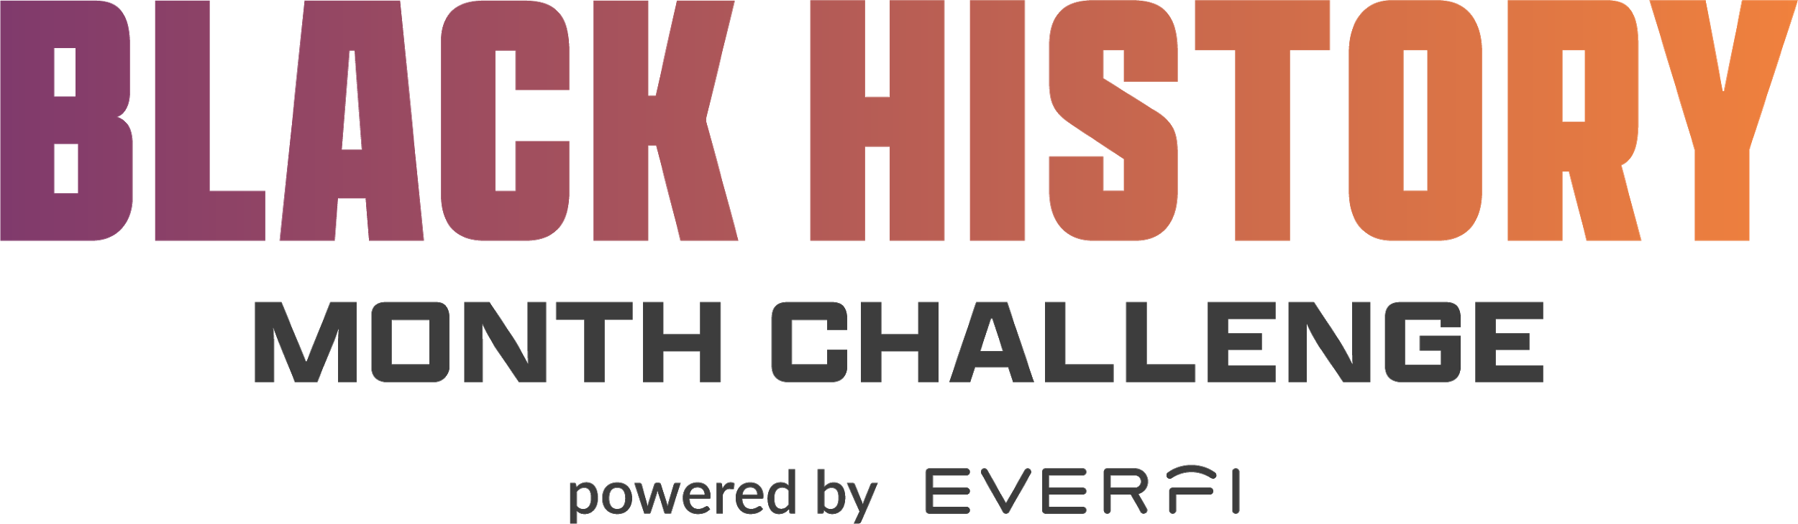
Suggested Social Media Language

General Promotion
- To understand what’s happening in our world today, we must reflect on what has happened in the past. Explore the often #UntoldStories of influential Black Americans who helped pave the way for so many today. Join the #BlackHistoryMonth Challenge to learn more. [Link]

- There are many significant events that have shaped a diverse Black experience in the United States -- and there is often more to the story than what we learn in textbooks. Take the #BlackHistoryMonth Challenge to learn more about #UntoldStories, Black business titans, and Black contributions to medicine! [Link]

- Do you know what counter storytelling is? Let’s take a look at untold perspectives and experiences of Black people in the U.S. so we can better understand our world today. Take the #BlackHistoryMonth Challenge to learn more. [Link]

- Be inspired by hearing the often #UntoldStories about the Black experience in America. Take the #BlackHistoryMonth Challenge and get a glimpse into the triumphs over adversities led by many Black Americans across generations. [Link]

- Current events are often best understood through the lens of what has happened in the past. By exploring the #UntoldStories that are often left out of our textbooks, we get a fuller picture of history to better understand the world around us. Take the #BlackHistoryMonth Challenge to learn more. [Link]

Untold Stories

- Juneteenth is a holiday that celebrates the end of racial enslavement in the United States -- more than two years after the Emancipation Proclamation. Take the #BlackHistoryMonth Challenge to learn about the rich history and traditions surrounding this holiday, plus much more! [Link]

- After more than 50 years of affirmative action in higher education, the courts and colleges still can't agree on the role of race in college admissions. Learn the full story by taking the #BlackHistoryMonth Challenge. [Link]

- Although the Black Lives Matter protests of 2020 and the Million Man March of 1995 happened decades apart, they share many similar themes. What can we learn from the past to understand the present? Take the #BlackHistoryMonth Challenge to learn the full story. [Link]

Black Business Titans

- Today we’re exploring the theme of inequitable opportunity and the experiences of Black entrepreneurs who have had to work against privilege in order to overcome many obstacles and achieve business success. Follow along to see how the story unfolds. [Link]
- Learn the #UntoldStories behind the rise of Black Wall Street and how Black businesspeople have pushed through adversity on their path toward success. [Link]

- The Golden Age of Black Business was a period where more opportunities were provided to previously enslaved Black people. Learn the #UntoldStories of several Black entrepreneurs and how they rose to success and overcame challenges. [Link]

- There are six million total businesses in the US with employees, but how many of them are Black-owned? Take the #BlackHistoryMonth Challenge to find out. [Link]

- Madam C.J. Walker is recorded as the first female self-made millionaire for her international hair care business. She achieved this impressive feat during a time of racial and gender discrimination. Take the #BlackHistoryMonth Challenge to uncover the stories of other noteworthy Black business owners and learn their #UntoldStory. [Link]

Black Contributions to Medicine
- Since 1951, Henrietta Lacks’ cells have been used to make groundbreaking contributions to medical research, but for decades, her family received no financial reparations. Hear Henrietta’s #UntoldStory and the incredible impact she’s had on modern medicine by taking the #BlackHistoryMonth Challenge. [Link]

- Studies show that people are more likely to seek medical treatment from physicians that share similar backgrounds, but only 7% of medical graduates are Black. Read about the inspiring medical trailblazers who have advocated for representation in medicine and how they’ve improved health outcomes for the Black community. [Link]

Capstone Essay Push
- Thank you to all of the students who have opted into the #BlackHistoryMonth Challenge! Now it’s time to put this knowledge to work by submitting the capstone essay and competing to win a $2,500 college scholarship! How will you keep the conversation about Black history going year-round? Not sure where to start? It can be as simple as sharing Black stories, uplifting Black authors, supporting Black businesses, or having conversations with friends and family.

- History isn’t just what happened in the past—it’s also what’s happening right now, every day. That’s important to remember because it means progress can continue daily and our generation can have a say in what happens next. Take the #BlackHistoryMonth Challenge and share how YOU will keep the conversation about Black history going year-round. You could win a $2,500 scholarship! [Link]

Final Activation Push
- Have you heard? Complete the #BlackHistoryMonth Challenge by February 28th to be eligible to compete in the capstone essay contest and compete to win a $2,500 scholarship! Don’t wait, get started today.
- Calling all high school students! This is the last call to participate in the #BlackHistoryMonth Challenge. Complete the challenge by February 28 to be eligible to win a $2,500 scholarship!
- Parents: looking for a way to celebrate Black History Month with your high schooler? Through the end of February, they can participate in the #BlackHistoryMonth Challenge! Students must complete the 30-minute lesson and submit a capstone essay for a chance to win a $2,500 college scholarship!

