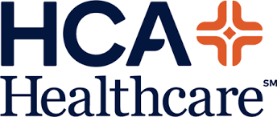

PROGRAM TALKING POINTS:

- [HOSPITAL BRAND] is incredibly proud to announce the launch of an important mental wellness education program in partnership with leading education technology provider, EVERFI.
- Beginning in the Fall of 2021, [HOSPITAL BRAND] has provided access to Understanding Mental Wellness to schools across [INSERT COUNTIES] - all at no-cost to the school or teacher.
- The digital course Understanding Mental Wellness is designed to empower middle and high school students with the knowledge and skills necessary to build, maintain and promote positive mental health in themselves and their peers.
- As we know, mental health is one of the most important health issues in our country and with the devastating impact of COVID-19, it has become even more critical to provide our youth with the support they need.
- The Understanding Mental Wellness course utilizes a population-level approach to what is often viewed as an individual issue. The digital course provides students with opportunities to explore their own mental health, identify challenges that they may face, and develop concrete strategies for managing those challenges, while increasing their awareness of resources and empowering them with the knowledge, skills, and language necessary to identify and support a peer who may be struggling.
- At [HOSPITAL BRAND] we are dedicated to supporting our youth by providing effective prevention education. This program not only addresses the critical health needs of the communities we serve, but also has a positive and lasting impact for students by helping prevent significant mental health issues in the future.

