**HCA Healthcare’s *Understanding Mental Wellness* Program: Facts Sheet**

Updated September 2024

**| ABOUT THE PROGRAM:**

* HCA Healthcare has partnered with EVERFI since 2020 on the *Mental Wellness Basics* program, refreshed and renamed in 2022 to *Understanding Mental Wellness*, an interactive, mental health and wellness education course to middle and high school students across select markets.
* *Understanding Mental Wellness* is designed to equip students in grades 8 to 10 with the knowledge and skills necessary to build, maintain, and promote positive mental health in themselves and their peers.
* The *Understanding Mental Wellness* program first launched in select schools across Colorado, Florida, Kansas, Missouri, North Carolina, and Texas, and has since expanded to also include select schools in Alaska, California, Georgia, Idaho, Louisiana, Nevada, South Carolina, Utah, and Virginia.
* The communities were selected to align with the hospitals and facilities which fall under HCA’s 15 US Divisions.

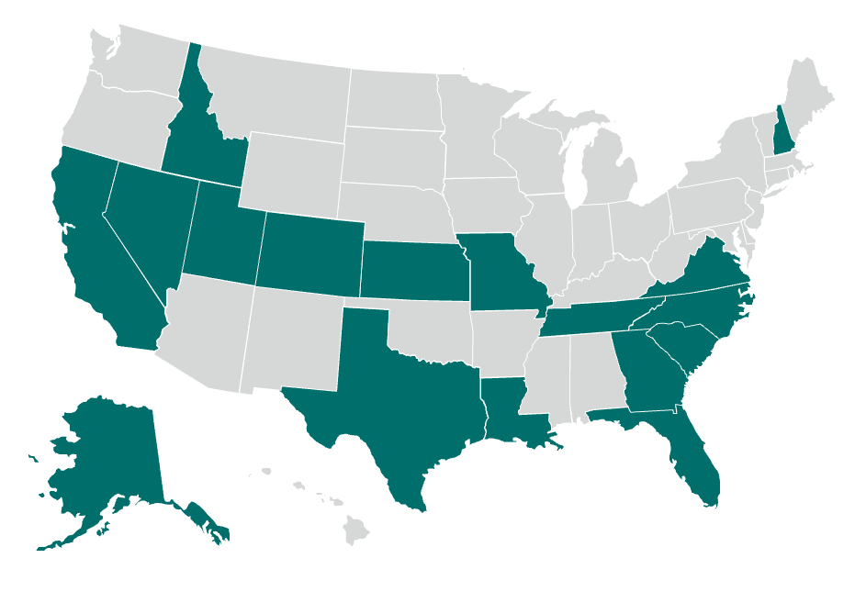

**| PROGRAM IMPACT:**

* Since launchingin Fall 2020, HCA Healthcare has impacted over 232,000 students across more than 1,100+ unique schools.
* After taking the course, 81% of students say this course helped them understand how to help a friend in need.
* After taking the course, 83% of students said they are confident they know what they need to do to stay mentally healthy.

**| TESTIMONIALS:**

* “I learned ways how I can make sure that my mental health is balanced and that   
  no matter how little or big the mental problem is I should get help because even if it is little it could turn into a big problem in the future.” - Student, Colorado
* “I like how this course focused on mental health which is a very important topic that I feel everyone should be more about… I know that when I’m stressed I should take some time out of my day to analyze what is causing my stress. I could also talk to a trusted adult to give me some advice, and to realize I’m not alone.” - Student, Florida

**| RESOURCES:**

[External Program Page](https://hcahealthcare.everfi.com/)

[Internal Resource Hub](https://resources.everfi.com/toolkits/hca-healthcare-everfi-program-resource-page/)

**| EXPLORE THE COURSE:**

To access a demo version of the *Understanding* *Mental Wellness* program, please visit [everfi.com/register](http://everfi.com/register) and use the following code to register: **hcahealthcaredemo**.